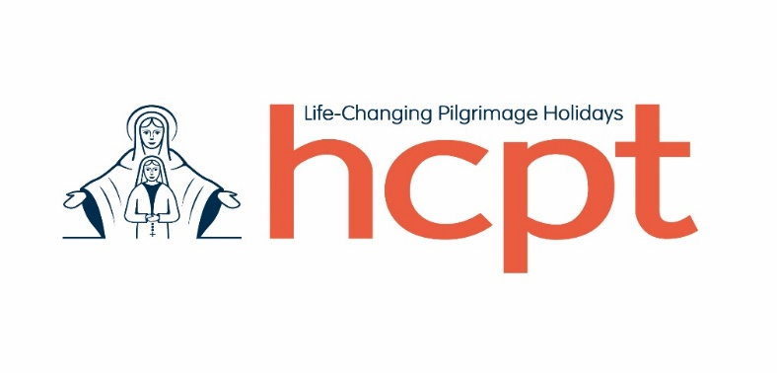
London Marathon 2025 Application Form
Thank you for expressing an interest in running the London Marathon in support of HCPT. The event will take place on Sunday the 27th of April 2025 (at the tail end of our Easter pilgrimage) and is a great fundraising opportunity.
Please note that each guaranteed charity place costs £350 which has to be paid to HCPT in advance. By submitting the form you agree to pay the entrance fee of £350 by 1st October 2024 in case if you are a successful candidate for the HCPT London Marathon place.
We’d really appreciate if anyone willing to participate in the London Marathon 2025 have initially applied for the ballot place, for us to enable the charity have as many places in the event as possible. It’ll give a chance to more HCPT groups to raise money for their beneficiaries using this powerful fundraising tool.

Also when distributing the HCPT charity places for the London Marathon 2025, priority will be given to those applicants who are ready to fundraise centrally. Only in case if there are available places left, they will be distributed between the applicants who are raising money for a particular pilgrimage group.

To apply for one out of five HCPT Golden Bond charity places please complete the short questionnaire below and email it to me at olha@hcpt.org.uk at your earliest convenience. The deadline for the applications is 1st July 2024.
- Your name and surname _______________________________________________

- Have you run a similar distance in the recent past? If so, tell us about it.

- What is your connection with HCPT? How and when did you first get involved? HCPT?The Marathon places cost the Trust £350 each and represent a great

- Please indicate how much sponsorship you think you could raise by running the Marathon for HCPT. Please be realistic. (Underline the range below)

£1,000-£1500 £1,500 - £2,000 £2,000 - £2,500 £2,500 - £3,000

£3,000+

- How would you raise the amount specified? Who would you approach and how?

- Please indicate (by underlining) whether you plan to run for

- HCPT generally (centrally)
- For a specific HCPT group (mention its number below)

- Please indicate below your contact mobile number and email address, which can be used for communication with you regarding the London Marathon 2025

Mobile number ___________________________________
Email address: ___________________________________
- Have you applied for a London Marathon 2025 ballot place to increase your chances? (underline the correct answer)

  - Yes
  - No

- Any other comments you’d like to make

Thank you for taking the time to complete the Application Form. You’ll be informed of the results by email by 15th August 2024

