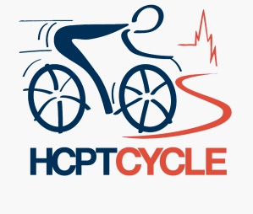
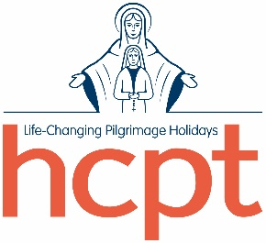

HCPT Cycle 2025

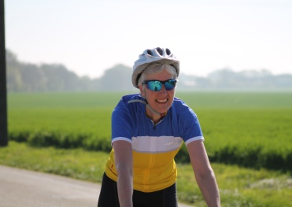
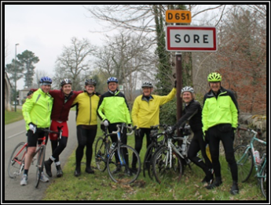
Are you looking for a challenge and want to help make a difference at the same time?

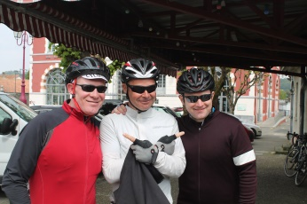

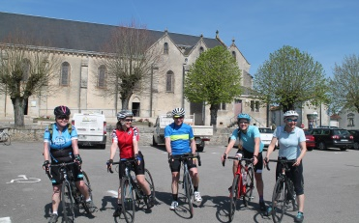

Thousands of disabled children and adults have enjoyed unforgettable pilgrimage holidays to Lourdes in France - because of HCPT.

Volunteer helpers accompany those travelling to Lourdes, meaning families and carers back home in the UK can get some much needed respite.

The pilgrimage holidays have been organised by HCPT, a registered charity, for over 60 years, and are only possible thanks to the generosity of our supporters.

Our Easter pilgrimage holiday is focused on disabled children, who stay in hotels in Lourdes. Our Summer pilgrimage holidays are for disabled people of all ages, who stay at our Hosanna House “home from home” near Lourdes. All pilgrimage holidays are life changing experiences for those taking part.

Questions you may have;

How hard is this going to be?
A wide range of people take part in this event, from very experienced cyclists to those who have only taken up cycling to complete this event. Training and preparation is key to completing the cycle. It starts just outside Paris in Versailles and finishes in Lourdes. The total distance is 550 miles, between 50 and 115 miles a day. (The route may be subject to change).

When is it happening?
The cycle takes place over seven days starting Saturday 12th April 2025 and finishing on Good Friday, 18th April 2025, with return home on Sunday 20th April.
What will I need?
You will need your own bike and cycle clothing, including cycle shorts, cycling jersey and cycling jacket.

What sort of bike do I need?
This is a personal choice, but we strongly recommend a Racing or Sports type of bike. The lighter the bike the easier it is to push!

What about the cost and fundraising?
All participants, cyclists and backup team will need to pay a fare of £850, which covers travel, food, insurance and accommodation (min two-three star on a sharing basis). We ask everyone on the trip to commit to raising £2,000.

Do I have any obligations to meet before the cycle? (meetings/practise)
There will be four practise cycles that cyclists and backup team will be requested to attend at their own expense – a diary of dates is given on the next page. This is to ensure that we can give ongoing support for your training and to provide further information about the trip.
What sort of support will be provided during the cycle?
As well as organising transfers to Versailles, dinner, bed and breakfast each night, transport of the baggage and food stops on the road, we will also arrange return flights to the UK.

If I am joining my group in Lourdes, what will my fare be for the week?
Cyclists wishing to stay on will pay an additional fee, dependent on your role on the pilgrimage, and your group’s hotel, length of stay and means of return travel. This cost will be confirmed to you in October.

Support and advice will be given on what type of equipment you need and also ways you can reach your fundraising target.

Important points to remember…

- You need your own bike and clothing
- You must protect your grey matter and wear a helmet at all times when cycling with HCPT.
- Cover the cost of your trip (£850)
- Fundraise a minimum of £2,000
- Meet up with and train as a group on our training days (dates on back).

If you are interested…
If you are interested in taking part in the cycle, please complete the form below and return to HCPT at the address on the back of this form. Alternatively, please send an e-mail providing the information listed to: joan.cycle@hcpt.org.uk

Name ________________________

Address_______________________________________________________________________

Post Code _________________ Tel : ______________________

E-Mail : ____________________

I’m interested in :

Cycling

Being part of the support team (see below)

If support team, please give details of any appropriate skills/experience _______________________________________________________________________________

We have a limited number of spaces available in our support team, and places will be allocated, ensuring we have an adequate skills mix, on a first come first served basis.

Diary Dates for HCPT Cycle 2025

13th – 14th July 2024 | Initial meeting and cycle 40 miles
1st October 2024 | Closing date for 2025 Cycle applications
12th – 13th October 2024 | 2nd Preparation weekend 60-mile cycle
31st October 2024 | 2nd instalment of fare due
31st January 2025 | Final balance due
1st – 2nd March 2025 | 3rd Preparation weekend. 30-mile cycle Saturday, 60-mile cycle Sunday
5th – 6th April 2025 | Final preparation weekend 70-mile cycle
12th April 2025 | Travel to Versailles and commence cycle
18th April 2025 | Arrive Lourdes
20th April 2025 | Easter Sunday & return flight

HCPT
Oakfield Park
32 Bilton Road
Rugby
Warwickshire
CV22 7HQ

Tel : 01788 56 46 46

E-mail : joan.cycle@hcpt.org.uk
Web : www.hcpt.org.uk

